Use Cases

1. **Cultural or historical data generator:**

            i. User need to enable the web extension on browsing the website .

ii. User need to highlight the keyword which he/she need a summarized information about the keyword

iii. Once user highlights the text a dialog box with three options will pop up

i.e Historical details,Dictionary meaning,others.

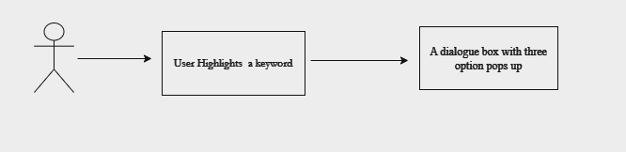

1. **Historical Details generator:**

            i. When user highlights the text a dialog box with three options will pop up

ii. User need to Click on the ‘Historical details’ option button and click on apply button.

iii. Once user clicked on the apply button a dialogue box with summarized historical data will be displayed

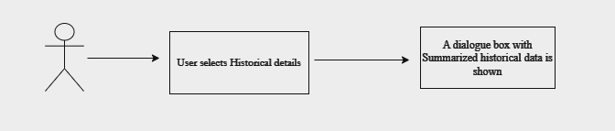

1. **Dictionary meaning generator:**

            i. When user highlights the text a dialog box with three options will pop up .

ii. User need to Click on the ‘Dictionary meaning’ option button and click on apply button

iii. Once user clicked on the apply button a dialogue box with dictionary meaning of the keyword will be shown.

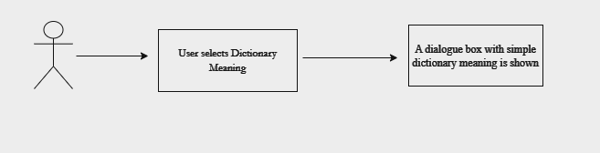

1. **Other Data generator:**

            i. When user highlights the text a dialog box with three options will pop up.

ii. User need to Click on the ‘other’ option button and click on apply button

iii. Once user clicked on the apply button a dialogue box with “input your text” box will appear.

iv.User can enter the text there and click on search button,then a dialogue box with open ai response will be displayed with ‘search more’ option

v.User can continue again with user input text using ‘search more’ option

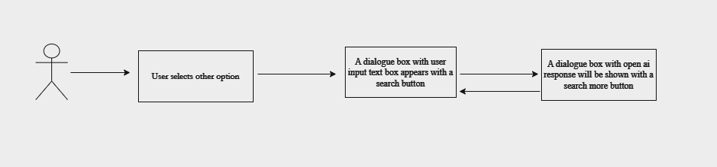

High Level Design:

1. Store API keys
2. Take user input
3. Call OpenAI APIs and pass the prompt
4. Display the response of appropriate dialogue box in Web extension

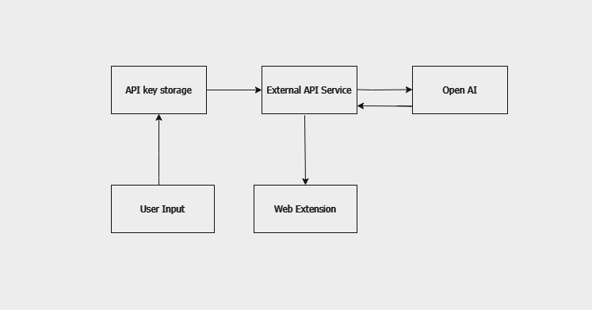

Screen:

